

Project Report: Smart Assignment System

Executive Summary

Project Name: Smart Assignment Management System

Project Duration: 30 days

Project Team: YP

Faculty Name: Mr.Moghal .Yaseen Pasha

|  |  |  |
| --- | --- | --- |
| Mentor(s) Name | : | Mr. Mahidhar |

Project Sponsor: IBM Smart Bridge

Date: 10.9.2023

Table of Contents

1. Introduction
2. Project Objectives
3. Project Scope
4. System Overview
5. Features and Functionality
6. Technology Stack
7. Project Methodology
8. Project Implementation
9. Testing and Quality Assurance
10. Project Management
11. Conclusion
12. Future Enhancements
13. References

**1. Introduction**

The Smart Assignment Management System is a web-based application designed to revolutionize the assignment management process in educational institutions. This project aims to enhance collaboration among students, teachers, and administrators while automating assignment creation, submission, grading, and feedback.

**2. Project Objectives**

The primary objectives of the Smart Assignment Management System are as follows:

To streamline the assignment management process, making it more efficient and less time-consuming.

To promote collaboration between students and teachers.

To provide a secure and user-friendly platform for assignment submission and grading.

To automate assignment notifications and reminders.

To improve educational outcomes through enhanced communication and efficiency.

**3. Project Scope**

The project's scope includes the following key features:

User authentication for students, teachers, and administrators.

Assignment creation and management by teachers.

Secure assignment submission with file uploads.

Assignment grading and feedback.

Assignment notification and reminder system.

User-friendly web interface.

**4. System Overview**

The Smart Assignment Management System is a comprehensive platform that integrates assignment creation, submission, grading, and communication features. It provides a central hub for students, teachers, and administrators to manage assignments efficiently.

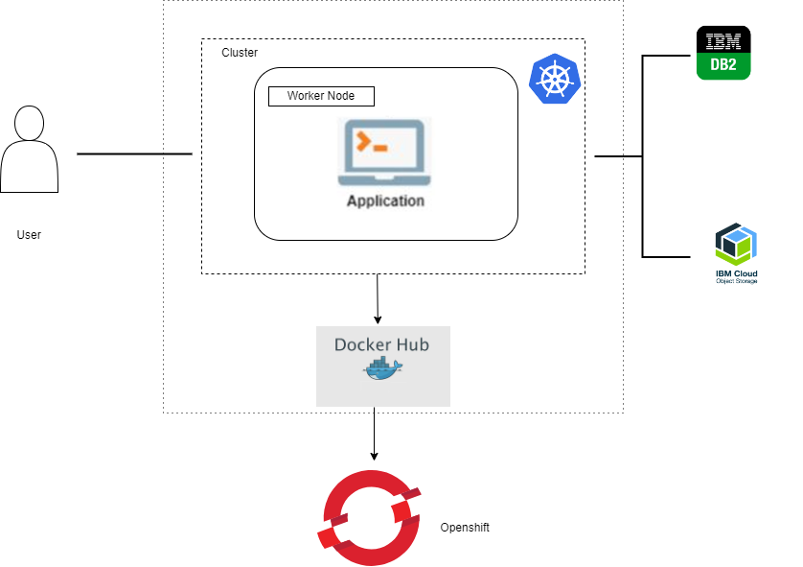

**5. Features and Functionality**

**5.1 Student Features**

Assignment submission with file uploads.

Access to assignment due dates and details.

Assignment notification and reminder system.

Viewing assignment grades and feedback.

**5.2 Teacher Features**

Assignment creation and management.

Grading and providing feedback to students.

Communication with students regarding assignments.

Assignment notification and reminder system.

**5.3 Administrator Features**

User account management.

Monitoring system usage and performance.

Managing system configurations and settings.

**6. Technology Stack**

The Smart Assignment Management System leverages the following technologies:

Front-end: HTML5, CSS3, JavaScript

Back-end: Python, Flask Framework

Database: IBM DB2

Hosting: IBM CLOUD

Security: HTTPS, User Authentication

**7. Project Methodology**

The project follows an DevOps development methodology, allowing for iterative development and flexibility in responding to user feedback and changing requirements. Regular meetings and collaboration among team members are key components of the development process.

**8. Project Implementation**

The implementation of the Smart Assignment Management System includes the development of both the front-end and back-end components. Security measures are implemented to protect user data and ensure secure file uploads.

Project along with screenshots.



index.html



**Faculty profile**



Admin Page

**9. Testing and Quality Assurance**

Thorough testing, including unit testing, integration testing, and user acceptance testing, is conducted to ensure the system's reliability and performance. Quality assurance processes are in place to identify and address any issues.

**10. Project Management**

Project management tools and techniques are employed to track progress, manage tasks, and meet project milestones. Regular communication with stakeholders is maintained to keep them informed of project status.

**11. Conclusion**

The Smart Assignment Management System aims to revolutionize assignment management in educational institutions by automating and streamlining the process. It fosters collaboration, enhances communication, and ultimately contributes to improved educational outcomes.

**12. Future Enhancements**

Future enhancements to the system may include additional features such as discussion forums, real-time chat, and advanced analytics to further improve the learning experience.

**13. References**

<https://www.python.org>

<https://cloud.ibm.com>

<https://w3schools.com>

This project report provides an overview of the Smart Assignment Management System, its objectives, scope, features, technology stack, methodology, and implementation. The system is designed to enhance assignment management, promote collaboration, and improve educational outcomes in educational institutions.